In vitro enhanced accumulation of polyphenols during somatic embryogenesis in Plantago ovata Forsk
Shonima Talapatra and Sarmistha Sen Raychaudhuri *

Plant Tissue Culture and Molecular Biology Laboratory, Department of Biophysics, Molecular Biology and Bioinformatics, University of Calcutta, 92, Acharya Prafulla Chandra Road, Kolkata 700009, India.
E-mail: sarmistha_rc@rediffmail.com, Tele Phone: +91(0) 332-3508386 (Extn: 324), Fax: +91(0) 332-8661573
*Corresponding author
Published: June 9, 2012 Received: May 07, 2012
AJBBL 2012, Volume 01: Issue 01 Page 43-52 Accepted: May 30, 2012

ABSTRACT
Plantago ovata Forsk (common isabgul) is much known for its medicinal importance. It is a potential source of bioactive compounds like polyphenols which serve as natural antioxidant having an ability to quench cytotoxic free radicals that are preventive to many diseases. In present investigation, the accumulation of polyphenolic compounds was studied during in vitro somatic embryogenesis in Plantago ovata. Calli of three different developmental stages during somatic embryogenesis were selected for this purpose and total polyphenol content was determined spectrophotometrically using Folin-Ciocalteu reagent. The embryogenic calli were found to contain highest level of polyphenolics. Further, the effect of exogenous additives like casein hydrolysate and coconut water on the accumulation of total polyphenol was also included into the study. 42 days old calli were treated with different concentrations of casein hydrolysate (1 gL⁻¹, 2 gL⁻¹, 3 gL⁻¹) and coconut water (5%, 10%, 15%) and used for total polyphenol content determination. 2 gL⁻¹casein hydrolysate and 5% coconut water produced the best result. So the study shows a greater promise in advancing the use of Plantago ovata for producing phenolic compounds in a larger scale.

INTRODUCTION
Plantago ovata Forsk, the common isabgul has gained importance throughout the world for its wide variety of medicinal properties. It is a bushy annual herb indigenous to Asia, Mediterranean region and North Africa. In India it is cultivated in Gujarat and Rajasthan. Plantago ovata has recently claimed economic importance for its immense use in agricultural, pharmaceutical, cosmetic and food industries worldwide. The seed husk of Plantago ovata are used as laxatives [1]. The mucilage contained in the seed coat is used as a stabilizer in ice cream; chocolate etc [2]. Plantago ovata is a rich source of different kinds of biologically active compounds among which polyphenols are of great importance. In recent years polyphenols have gained much attention due to their beneficial implications on human body. Polyphenols represent a large group of heterogeneous bioactive compounds produced in many medicinal and vegetable plants during their secondary metabolism. The position of hydroxyl or phenol group in the polyphenolic compounds are believed to determine their antioxidant properties, especially against peroxyl and superoxide radicals [3]. A broad spectrum of polyphenolic compounds includes simple molecules like phenolic acids to large polymers like tannins. Most important beneficial aspect of polyphenolic compounds in human health is their antioxidant activities and free radical scavenging abilities which have been well explored during recent years [4]. Several studies have documented the ability of polyphenols in quenching cytotoxic reactive oxygen species (ROS) as well as their role in metal ion chelation [5]. Polyphenols are also known to have antiulcer [6], anticarcinogenic, antimutagenic [7], anti-inflammatory [8] and antiviral [9] activities. Accumulation of polyphenolic compounds in embryogenic tissues during somatic embryogenesis has been previously reported in many plants [10, 11]. Previous studies have shown that polyphenolic compounds increases with the age of callus tissue in chick pea [12]. Phenolic compounds are intermediates of phenylpropanoid pathway and their production is regulated by the differential expression of basic genes [13, 14]. Phenolic compounds can be induced by several abiotic stresses like ethylene, methyl jasmonate, temperature, light and wounding [15]. Therefore studying effect of external additives like casein hydrolysate and coconut water on total polyphenol content during in vitro somatic embryogenesis in Plantago ovata would be of utmost importance. Casein hydrolysate and coconut water are widely used additives in plant tissue culture experiments. Casein hydrolysate is a rich source of amino acids and coconut water, the liquid endosperm of coconut is known to contain cytokinins. Therefore, both casein hydrolysate and coconut water may play a role in inducing the expression level of basic genes involved in polyphenol biosynthesis. The present investigation was therefore intended to determine the effect of exogenous additives on total polyphenol content during in vitro somatic embryogenesis in Plantago ovata.

MATERIALS AND METHOD

Tissue culture: Seed sterilization

Seeds of Plantago ovata were procured from Gujarat (India).Plantago ovata seeds were surface sterilized in 10% sodium hypochlorite (commercial bleach) solution for 20 min with vigorous shaking and washed four to five times (each 5 min) with sterile distilled water to remove excess bleach. Seeds were then imbibed overnight in sterile distilled water. Following imbibition the seeds were inoculated aseptically in germination medium containing 3% (w/v) sucrose (SRL, Mumbai, India) and 0.9% (w/v) agar (SRL, Mumbai, India) for germination.

Callus induction following the additive supplementation

Callus cultures were established using seedlings without roots as explants (~2-3 cm) from 10 day old germinated plants. Callus was initiated on MS (Murashige and Skoog) medium [16] containing 1 mgL⁻¹ 2,4-D (2,4-dichlorophenoxy acetic acid) and 0.5 mgL⁻¹ kinetin (6-furfuryl amino purine) as plant growth regulators and incubated over a period of 21 days (1st passage). The pH of the medium was adjusted within 5.6-5.8 (using 1N KOH) prior to autoclaving. The cultures were maintained in Plant Growth Chamber (GC-300TLH, Lab companion, Korea) at a temperature of 22ºC-25ºC and a relative humidity of 55%-60% under Philips fluorescent day light tubes emitting 32 x 10⁸ mole s ^{–1} m⁻² for 16/8 hrs duration in light/dark photoperiods. The calli were subcultured on the same medium with similar combination and concentration of plant growth regulators for another 21 days (2nd passage) to increase callus mass. Each culture with specific plant growth regulator combination was replicated five times.
To study the effect of additives on total polyphenol content in Plantago ovata, 42 days (2nd passage) old calli were transferred to MS medium containing 0.5 mgL⁻¹ NAA (α-naphthalene acetic acid) and 1 mgL⁻¹ BAP (6-benzyl amino purine) along with different concentrations of external additives like casein hydrolysate (Sigma Chemical, USA) and filtered coconut water (obtained from green and unripe coconut fruit) and incubated over a period of 21 days (3rd passage). 1 gL⁻¹, 2 gL⁻¹ and 3gL⁻¹ casein hydrolysate and 5%, 10% and 15% coconut water were used to treat the calli. Casein hydrolysate was weighed and added to the MS medium (w/v) along with 0.5 mgL⁻¹ NAA and 1 mgL⁻¹ BAP , made upto volume and heated in microwave oven to dissolve. Coconut water was first filter sterilized and added to the MS medium (v/v) along with the same plant growth regulator combination as in case of casein hydrolysate. A set of embryogenic calli without any additive supplementation was maintained as control in both the cases. The culture medium and the specific plant growth regulator combination and concentration had been chosen following the standardized tissue culture method reported in Plantago ovata by Das (Pal) and Sen Raychaudhuri (2001).

Extraction of total polyphenols from callus

Total polyphenol was extracted from 1st (21 days), 2nd (42 days) and 3rd passage (63 days) calli during somatic embryogenesis to identify the developmental stage at which maximum accumulation of polyphenolic compounds occurred. The calli showing maximum polyphenol accumulation were then treated with exogenous additives and total polyphenol extraction was done from the treated samples.
100 mg of plant tissue (calli) from each of the samples was finely crushed and homogenized in presence of liquid nitrogen and dissolved in 1ml of 50% HPLC grade aqueous ethanol (Merck, Germany). The mixture was then subjected to ultrasonication for 20 minutes followed by centrifugation at 10,000 rpm for 5 minutes to separate the clear supernatant. The supernatant was collected in a fresh tube and volume was made up to 1 ml with 50% aqueous ethanol (HPLC grade). Five samples were used for the extraction of total polyphenols in this case.

Spectrophotometric determination of total polyphenol content by FCR method

Total polyphenol content of control and treated samples were determined by Folin-ciocalteu reagent (FCR) method as discussed by Singleton with minor modifications [17]. 50μl plant extract from each sample was mixed with 250μl of Folin-ciocalteu reagent and 750μl of 10% sodium carbonate (Na₂CO₃) solution. The mixture was shaken well and incubated at room temperature for 30 minutes in dark. Following incubation absorbance was determined at 760 nm in a HITACHI UV-VIS (U-2800, Tokyo, Japan) spectrophotometer. The content of total polyphenol in each sample was expressed as μg Gallic Acid Equivalent (GAE)/ g fresh weight of tissue by comparing with the gallic acid calibration curve which was constructed beforehand with standard gallic acid.

Preparation of gallic acid calibration curve

In this study gallic acid was used as a standard polyphenolic compound to express total polyphenol content in the extracted samples. A gallic acid calibration curve was prepared for this purpose by taking a range of standard gallic acid (Sigma Aldrich, USA) concentrations from 0 to 50μg/ml. Each of the standard gallic acid solutions were reacted with Folin-ciocalteau reagent and sodium carbonate using above mentioned procedure and absorbances were recorded at 760 nm.

Statistical analysis:

All experimental results were represented as mean values ± SEM (standard error of the mean). The data were analyzed by an analysis of variance (ANOVA) and means were compared using Student’s t test using Microsoft Office Excel. All the experiments were replicated five times. Differences in the data at p≤ 0.05 were considered to be statistically significant.

RESULTS AND DISCUSSION

The present study was carried out to identify the developmental stage during in vitro somatic embryogenesis of Plantago ovata at which maximum accumulation of polyphenolic compounds occured and effect of exogenous additives on the accumulation of total polyphenols during somatic embryogenic development.

Tissue culture

Plantago ovata seeds were found to germinate within 7-10 days of inoculation in agar-sucrose medium. Initiation of callus from entire explants without the shoot tip was observed within 21 days of culturing on MS medium. The calli were soft, friable and light green in color at the first passage. Subculture increased the mass of calli in successive passages. The color and texture of the calli changed with passage of time. Calli were found to be nodular, compact and yellowish brown in color at the second and third passage. Somatic embryo formation was observed at the third passage (~60-65 days) when MS medium was supplemented with 0.5 mgL⁻¹ NAA and 1 mgL⁻¹ BAP (Figure 1).
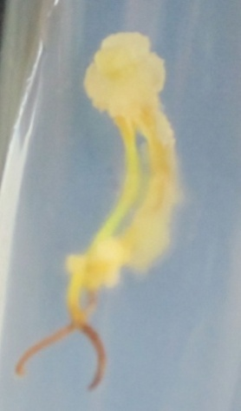 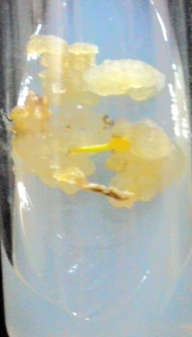 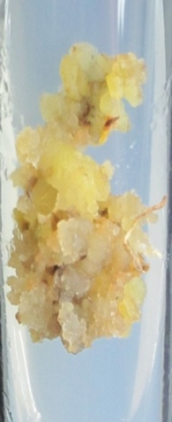
A B C
Figure 1: Callus of P. ovata at different developmental stages A: 1st Passage callus (21 days), B: 2nd Passage callus (42 days), C: 3rd Passage callus (63 days)

Application of plant additives to the culture medium has been attempted by many researchers to improve growth and differentiation of in vitro plant cultures [18]. For our study we have used casein hydrolysate and coconut water as plant additives. Casein hydrolysate serves as an excellent source of amino acids [19] and coconut water is known to contain diphenyl-urea having cytokinin like activity [20]. The addition of casein hydrolysate and coconut water along with 0.5 mgL⁻¹ NAA and 1 mgL⁻¹ BAP in MS media showed a positive influence in increasing callus mass. Similar observations have been reported by earlier studies in our laboratory [21]. Both casein hydrolysate and coconut water induced profuse callusing as compared to control (embryogenic calli without any additive supplementation). Calli of treated samples were more compact, nodular and brown in color (Figure 2 & 3).
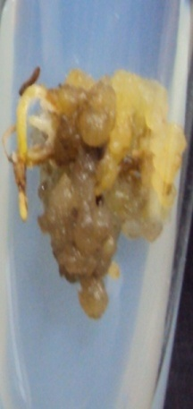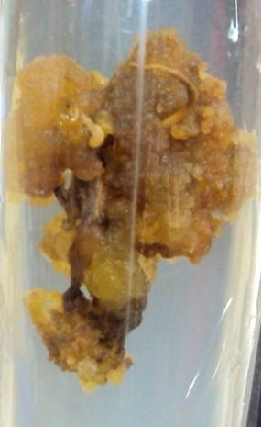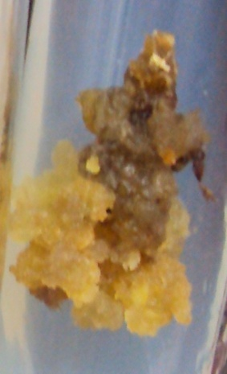
A B C
Figure 2: Callus of P. ovata treated with different concentrations of casein hydrolysate (CH) A: 1 gL⁻¹ CH, B: 2 gL⁻¹ CH, C: 3 gL⁻¹ CH

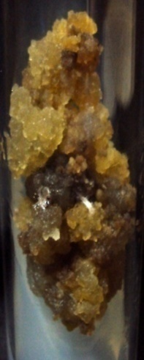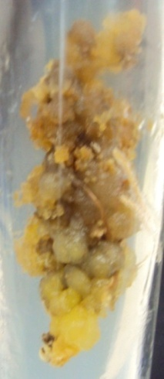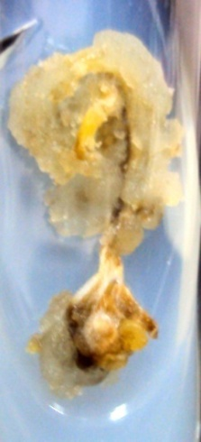
A B C
Figure 3: Callus of P. ovata treated with different concentrations of coconut water (CW)
A: 5% CW, B: 10% CW, C: 15% CW

Gallic acid calibration curve

The gallic acid calibration curve (Figure 4) was found to be linear across the concentration range assayed (0 to 50μg/ml). The linear regression equation of the gallic acid calibration curve was Y= 0.004X with a correlation coefficient of R²= 0.995. The total polyphenol content for each of the extracts was determined in terms of μg Gallic Acid Equivalent (GAE)/ g fresh weight of callus tissue with reference to the gallic acid calibration curve.
Figure 4: Gallic acid calibration curve

Spectrophotometric determination of total polyphenol content during somatic embryogenesis in Plantago ovate

Polyphenolic compounds are one of the most fascinating molecules in the field of medicinal plant research due to their antioxidant properties. Accumulation of polyphenolic compounds in embryogenic cultures of many plants has been previously reported by different groups of researchers [22]. Association of polyphenolic compounds with somatic embryo formation is well established [23]. The present study documented accumulation of polyphenolic compounds in the embryogenic cultures of Plantago ovata. Amount of total polyphenol was found to increase with developing stages of the calli. Highest polyphenol accumulation was observed in the embryogenic calli (~60-65 days) of Plantago ovata (Figure 5). The third passage calli contained 244±7.23 µg of total polyphenol/g fresh weight of the callus tissue. For this reason 42 days old calli were selected for treatment with external additives.

Figure 5: Total polyphenol content in different developmental stages during somatic embryogenesis in P. ovata. Each value is the mean with standard error of five replicates. Asterisks indicate significant differences at p < 0.05 (*) or p < 0.01 (**) or p <0.001 (***) between the means.

Figure 6: Effect of casein hydrolysate on total polyphenol content in P. ovata. Each value is the mean with standard error of five replicates. Asterisks indicate significant differences at p < 0.05 (*) or p < 0.01 (**) or p <0.001 (***) between the mean of the sample as compared to the mean of the control.
Figure 7: Effect of coconut water on total polyphenol content in P. ovata. Each value is the mean with standard error of five replicates. Asterisks indicate significant differences at p < 0.05 (*) or p < 0.01 (**) or p <0.001 (***) between the mean of the sample as compared to the mean of the control.

Effect of additives on total polyphenol content in Plantago ovata

Plantago ovata has always been well explored by researchers for phytochemical screening. Presence of different polyphenolic compounds in different species of Plantago has been reported in a number of studies [24-26] but enhancement of total polyphenol content in this species has not yet been established. Total polyphenol content greatly contributes to the antioxidant properties of many medicinal plants as evident from previous reports [27]. Effect of different organic additives and physical factors on total polyphenol content in plants has been extensively studied before [28-30]. In the present study we have attempted to enhance the total polyphenol content in Plantago ovata by supplementing exogenous additive to the embryogenic culture medium with an objective to develop an in vitro culture with enhanced amount of polyphenolic compounds. The supplementation of casein hydrolysate and coconut water along with 0.5 mgL⁻¹ NAA and 1 mgL⁻¹ BAP led to an increase in total polyphenol content. In case of casein hydrolysate total polyphenol content decreased when the additive was used in lower concentration (1 gL⁻¹). Lower concentration of casein hydrolysate might trigger a negative signal in the polyphenol synthesis pathway or it might be due to the decrease in the amount of one or more individual phenolic compounds which led to an overall decrease in total polyphenol content. Similar observations have been reported when plants are exposed to lower doses of salinity and gamma stresses [31, 32]. But in case of 2 gL⁻¹ casein hydrolysate a sharp increase in total polyphenol content was observed. Cultures treated with 2 gL⁻¹ casein contained 322.5±29.77 µg of total polyphenol /g fresh weight of callus tissue. Samples treated with 3 gL⁻¹ casein hydrolysate was found to contain greater amount of phenolic compounds than control but lesser than 2 gL⁻¹ casein hydrolysate. Hence 2 gL⁻¹ was considered as the best among other concentrations of casein hydrolysate in enhancing total polyphenol in Plantago ovata. Coconut water was also proved to be effective in enhancing total polyphenol in Plantago ovata. 5% coconut water was found to be maximally effective in enhancing phenolic compounds. Cultures supplemented with 5% coconut water contained 379.5± 17.49µg of total polyphenol /g fresh weight of callus tissue. But phenolic content was found to decrease with increasing concentrations of coconut water. 10% coconut water produced more phenolic compound than control but less than 5% coconut water. According to Das (Pal) and Sen Raychaudhuri (2001) higher concentration of coconut water enhances callus mass in Plantago ovata however, the authors did not study total polyphenol content. The increased callus mass might caused greater accumulation of total phenolics as compared to control. 15% coconut water was not found to be effective. Higher concentration of coconut water might cause degradation of polyphenolic compounds by different enzymes leading to an overall decrease in total polyphenol content. Embryogenic cultures supplemented with casein hydrolysate and coconut water were intensely brown in color. This may be attributed to the enhanced accumulation of phenolic compounds with callus ageing [33, 34] and the role of polyphenolic compounds in tissue browning [35, 36].

CONCLUSION

The results documented in the present investigation clearly indicated accumulation of polyphenolic compounds during somatic embryogenesis in Plantago ovata. In our investigation we have used casein hydrolysate and coconut water in different concentrations as external additives to enhance production of callus as well as total amount of polyphenolic compounds. Both the additives were proved to be effective in increasing the amount of total polyphenols in Plantago ovata. In the present article 2 gL⁻¹ casein hydrolysate and 5% coconut water gave best results in enhancing callus mass and total polyphenol content. However, 5% coconut water was found to be more effective as compared to 2 gL⁻¹ casein hydrolysate in enhancing total polyphenol content in Plantago ovata. The present article therefore would enrich new insights in the field of herbal formulations in biotechnological research.

ACKNOWLEDGEMENT:

The authors sincerely acknowledge UGC-DSA grant of the Department of Biophysics, Molecular Biology and Bioinformatics, University of Calcutta for financial support.

REFERENCES
- Pramanik S, Chakraborty S, Sen Raychaudhuri S. In vitro clonal propagation and characterization of clonal regenerants of Plantago ovata Forsk. by isozyme analysis. Cytobios. 1995; p123-130, Vol. 82.
- Pramanik S, Chakraborty S, Sen Raychaudhuri S. Changes in isozymes during in vitro morphogenesis in Plantago ovata Forsk. Plant Cell Tiss. Organ Cult. 1996; p123–127, Vol. 44.

- Rice-Evans CA, Miller NJ. Antioxidant activities of flavonoids as bioactive components of food. Biochem. Soc. Trans. 1996; p790–795, Vol. 24.

- Shon MY, Kim TH, Sung NJ. Antioxidants and free radical scavenging activity of Phellinus baumii (Phellinus of Hymenochaetaceae) extracts. Food Chem. 2003; p593-597, Vol. 83.
- Grubesˇic´ RJ, Vukovic´ J, Kremer D, et al. Spectrophotometric method for polyphenols analysis: Prevalidation and application on Plantago L. species. J. Pharmaceut. Biomed. 2005; p837-842, Vol. 39.

- Osakabe N, Sanbongi C, Yamagishi M, et al. Effects of polyphenol substances derived from Theobroma cacao on gastric mucosal lesion induced by ethanol. Biosci. Biotechnol. Biochem. 1998; p1535-1538, Vol. 62 (8).

- Kuroda Y, Hara Y. Antimutagenic and anticarcinogenic activity of tea polyphenols. Mutat. Res. 1999; p69-97, Vol. 436.

- Kiessoun K, Souza A., Meda NTR, et al. Polyphenol Contents, Antioxidant and Anti-Inflammatory Activities of Six Malvaceae Species Traditionally used to Treat Hepatitis B in Burkina Faso. Eur. J. Sci. Res. 2010; p570-580, Vol. 44 (4).

- Song J, Lee K, Seong B. Antiviral effect of catechins in green tea on influenza virus. Antiviral Res. 2005; p66-74, Vol. 68.

- Kouakou TH, Waffo-Te´guo P, Kouadio YJ, et al. Phenolic compounds and somatic embryogenesis in cotton (Gossypium hirsutum L.). Plant Cell Tiss. Organ Cult. 2007; p25-29, Vol. 90.

- Reis E, Batista MT, Canhoto JM. Effect and analysis of phenolic compounds during somatic embryogenesis induction in Feijoa sellowiana Berg. Protoplasma. 2008; p193-202, Vol. 232.

- Naz S, Ali A, Iqbal J. Phenolic content in vitro cultures of Chickpea (Cicer arietinum L.) during callogenesis and organogenesis. Pak. J. Bot. 2008; p2525-2539, Vol. 40 (6).

- Mamati GE, Liang Y, Lu J. Expression of basic genes involved in tea polyphenol synthesis in relation to accumulation of catechins and total tea polyphenols. J Sci Food Agric. 2006; p 459–464, Vol. 86.

- Chang J, Luo J, He G. Regulation of polyphenols accumulation by combined overexpression/silencing key enzymes of phyenylpropanoid pathway. Acta Biochim Biophys Sin. 2009; p123-130, Vol. 41(2).

- Reyes LF, Zevallos LC. Wounding stress increases the phenolic content and antioxidant capacity of purple-flesh potatoes (Solanum tuberosum L.). J. Agric. Food Chem. 2003; p5296-5300, Vol. 51.

- Murashige T, Skoog F. A revised medium for rapid growth and bioassays with tobacco tissue cultures. Physiol. Plant. 1962; p473-497, Vol. 15.

- Singleton VL, Orthofer R, Lamuela-Ravento´s RM. Analysis of total phenols and other oxidation substrates and antioxidants by means of Folin-ciocalteu reagent. Method. Enzymol. 1999; p152-178, Vol. 299.

- Al-Khayri JM. Influence of yeast extract and casein hydrolysate on callus multiplication and somatic embryogenesis of date palm (Phoenix dactylifera L.). Sci. Hort. 2011; p531-535,Vol. 130.

- Bister-Miel F, Guignard JL, Agier C. Glutamine as an active component of casein hydrolysate: its balancing effect on plant cells cultured in phosphorus deficient medium. Plant Cell Rep. 1985; p161–163, Vol. 4.

- Ishii Y, Takamura T, Goi M, et al. Callus induction and somatic embryogenesis of Phalaenopsis. Plant Cell Rep. 1998; p446-450, Vol. 17.

- Das (Pal) M, Sen Raychaudhuri S. Enhanced development of somatic embryos of Plantago ovata Forsk. by additives. In Vitro Cell Dev. Biol.-Plant. 2001; p568-571, Vol. 37.

- Alemanno L, Ramos T, Gargadenec A, et al. Localization and identification of phenolic compounds in Theobroma cacao L. somatic embryogenesis. Ann. Bot. 2003; p613-623, Vol. 92.

- Hilaire KT, Mongomaké K, Daouda K, et al. Trans-resveratrol as phenolic indicator of somatic embryogenesis induction in cotton (Gossypium hirsutum L.) cell suspensions. Afr. J. Biochem. Res. 2008; p015-023, Vol. 2 (1).

- Zubair M, Nybom H, Lindholm C, et al. Major polyphenols in aerial organs of greater plantain (Plantago major L.) and effects of drying temperature on polyphenol contents in the leaves. Sci. Hort. 2011; p523-529, Vol. 128.

- Fons F, Tousch D, Rapior S, et al. Phenolic profiles of untransformed and hairy root culturtes of Plantago lanceolata. Plant Physiol. Biochem. 1999; p291-296, Vol. 37 (4).

- Ga´lvez M, Marti´n-Cordero C, Houghton PJ, et al. Antioxidant activity of methanol extracts obtained from Plantago species. J. Agric. Food Chem. 2005; p1927-1933, Vol. 53.

- Chinnici F, Bendini A, Gaiani A, et al. Radical scavenging activities of peels and pulps from cv. Golden delicious apples as related to their phenolic composition. J. Agric. Food Chem. 2004; p4684-4689, Vol. 52.

- Fons F, Gargadennec A, Gueiffier A, et al. Effects of cinnamic acid on polyphenol production in Plantago lanceolata. Phytochemistry. 1998; p697-702, Vol. 49 (3).

- Wojdylo A, Oszmian´ski J, Bober I. The effect of addition of chokeberry, flowering quince fruits and rhubarb juice to strawberry jams on their polyphenol content, antioxidant activity and colour. Eur. Food Res. Technol. 2008; p1043-1051,Vol. 227.

- Devic E, Guyot S, Daudin J, et al. Effect of temperature and cultivar on polyphenol retention and mass transfer during osmotic dehydration of apples. J. Agric. Food Chem. 2010; p606-614, Vol. 58.

- Mane AV, Saratale GD, Karadge BA, et al. Studies on the effects of salinity on growth, polyphenol content and photosynthetic response in Vetiveria zizanioides (L.) Nash. Emir. J. Food Agric. 2011; p59-70, Vol. 23 (1)

- Gumus T, Albayrak S, Sagdic O , et al.Effect of gamma irradiation on total phenolic contents and antioxidant activities of Satureja hortensis, Thymus vulgaris, and Thymbra spicata from Turkey. Int J Food Prop. 2011; p830-839, Vol. 14.

- Ozyigit II, Kahraman MV, Ercan O. Relation between explant age, total phenols and regeneration response in tissue cultured cotton (Gossypium hirsutum L.) Afr J Biotechnol. 2007; p003-008, Vol. 6 (1)

- Ozyigit II. Phenolic changes during in vitro organogenesis of cotton (Gossypium hirsutum L.) shoot tips Afr J Biotechnol. 2008; p1145-1150, Vol. 7 (8).

- Laukkanen H, Haggman H, Kontunen-Soppela S, et al. Tissue browning of in vitro cultures of Scots pine: Role of peroxidase and polyphenol oxidase. Physiol. Plantarum. 1999; p337-343, Vol. 106.

- Khosroushahi AY, Naderi-Manesh H, Simonsen HT. Effect of antioxidants and carbohydrates in callus cultures of Taxus brevifolia: Evaluation of browning, callus growth, total phenolics and paclitaxel production. BioImpacts. 2011; p37-45, Vol. 1 (1).

