MS ajbbl03-01

A FAKE MEDICATED NAVAPASHANA HERBAL STATUE – A
FORENSIC CASE STUDY

Abstract
The medicated Navapashana Statue is very difficult to obtain and to make. It is commonly known as “Herbal Statue” and it is made of Navapashana, just like scientific preparations containing the essence of 473 Herbs, 9 kinds of Salts, 9 kinds of Pashana medicines, the milk from 9 kinds of other ancillary materials. Sridhar’s mix all the above ingredients in suitable proportions to make the disease curing Navapashana Statue. The Forensic Examination of Herbal Statue has been successfully employed by Forensic Science Laboratory, Chennai 600 004 to differentiate the Fake Herbal Statue from the original. This paper attempts to explain a case study of Herbal Navapashana Statue in detail with various analytical procedures.
Key Words: Forensic Chemistry, Navapashanam Herbal Statue, Atomic Absorption Spectrometry and Simulation.
Introduction
Siddhars dealt with 11 metals, 64 Pashanam (mercurial and non-mercurial’s), 120 Uparasams (salts and their minerals) and animal products in preparing medicines. The common preparations are Bhasma (Calcined metals and minerals), Churna (powders), Kashaya(decoctions), Lehya(confections), Ghirta(ghee preparations) and Taila(oil preparations). The preparation in which the Siddhars specialized are Churna (metallic preparations) which become alkaline, Mezhugu(waxy preparations), Kattu(preparations which are impervious to water and flame). For a medicine to be effective, the inorganic substances have to be brought into their atomic form. The Siddhars developed the knowledge of bringing inorganic substances into atomic and ionic form which can be easily absorbed in the system, when ground with herbal juices and put in the fire with a calculated number of cowdung cakes.
Mercury plays a very important place in Siddha medicine. Five forms of Mercury are normally available. Pashanam drugs do not dissolve but give off vapours when put into fire. The chemical constituents of Navapashanam are Veeram(Mercuric Chloride), Rasam(Mercury) Pooram(Arsenic-Camphor), Lingam(Calcinated powder of Cinnabar-Red Sulphide of Mercury), Rasakarpooram(Calomel-Hg₂Cl₂), Gandhakam(Sulphur),
Manochillai (Arsenic disulphide), Karmugil(Oxide of Iron) and Thaalagam(Yellow Arsenic-Yellow Sulphide of Arsenic). The only Navapashana Herbal Statue is available at Palani, Tamil Nadu as Dhandayuthapani Murugan Statue which is a medicated Statue and the prasathams from the Herbal Statue is used to cure various diseases.
A case of Medicated Herbal Statue was received at Chemistry Division of Forensic Science Department, Chennai 600 004 for examination to find out its nature and genuinity of the Statue. A study was undertaken to find out the level of metallic constituents like Mercury, Arsenic, Lead, Tin, Copper, Iron, Zinc & non-metal like Sulphur in the Case Sample to find out whether the Statue is original or fake.

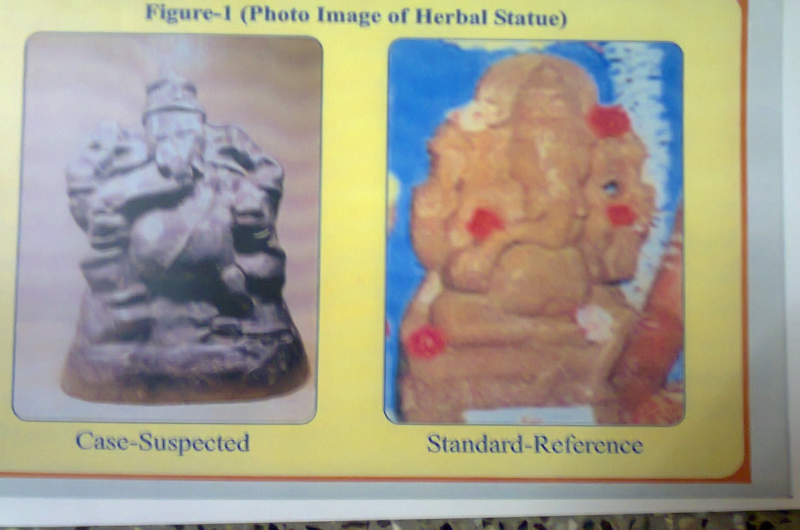
Figure-1 (Photo image of Herbal Statue)

2. EXPERIMENTAL AND METHODS
2.1 REAGENTS
1. Reference Standard Navapashana Herbal Statue – Powder obtained from Siddhar Jeyaraman, International Mooligaimani Manthrika Navapashana Siddhar, Chennai.
2. Case Sample of suspected Navapashana Statue, reffered to FSD, Chennai
600 004 (scrapings from the statue was taken up for examination).

3. Conc.HNO₃ (AR Grade)
4. Water – double distilled and deionised
5. Standard solutions of Hg, As, Pb, Cu, Fe & Zn are utilized for Atomic Absorption
Spectrometry
6. Benzene (AR Grade)
7. Chloroform (AR Grade)
8. Methylene Chloride (AR Grade)
9. Acetone (AR Grade)

2.2 METHOD
2.2.1 SAMPLE DIGESTION
About 2grams of the reference standard Herbal Powder was taken and about 10ml of concentrated Nitric Acid (AR Grade) was added and digested over hot water bath maintained at 80ºC for 2hours and cooled. Then the digested material was filtered through a previously weighed Whatman No.1 Filter paper and the filtrate was made up to known volume (100ml/250ml in a calibrated standard flask). The acid insoluble residue was dried in an air oven at 110ºC for an hour. The filter paper along with the residue is kept in a dessicator and weighed. The difference in weight gives the percentage of acid insoluble residue which normally includes Sulphur and Tin as hydrated Stannic Oxide (SnO₂ H₂O).
Similarly, the scrapings from different parts of the Case sample were taken and subjected to the same procedure, as explained above.
Preliminary qualitative tests were carried out with the filtrate of Standard and Case Sample for the detection of Hg, As, Pb, Cu, Fe & Zn. Quantitation was carried out with the filtrate of Standard and Case sample by volumetry and gravimetry methods, depending upon the quantity of each element, it was further confirmed by Instrumental methods. Based on the results from conventional methods, suitable dilutions were made and subjected to Atomic Absorption Spectrometry.
2.2.2 SAMPLE EXTRACTION
The acid insoluble residue leftover was extracted with Benzene. The extraction was continued till the residue was free from Sulphur. The combined benzene extracts were collected in a previously weighed glass dish and evaporated over an hot water bath to dryness. After evaporation, the dish was cooled and weighed. The difference in weight gives the percentage of Sulphur. Sulphur can also be determined by direct solvent extraction from the scrapings and also by gravimetry method by converting it into sulphate and precipitated as BaSO₄. The results are tabulated in Table:3.
Chloroform extract of the Standard Sample and Case Sample were taken and evaporated to dryness. The dried extract was dissolved in chloroform and subjected for examination by chromatography.
2.3 INSTRUMENT
Varian Atomic Absorption Spectrometer model Spectra AA 220 series with computing integrator was used for the analysis. The experimental conditions for the determination of Hg, As, Pb, Cu, Fe & Zn by Flame Atomic Absorption Spectrometry (FAAS) are summarized in Table:1.
2.4 METHOD
Determination of the elements was carried out after digestion of the material. Calibrate the instrument using reference standards. The calibration graph was drawn using computer integration system. Atomize the digested Standard Navapashana Herbal Powder and the Case Sample simultaneously. The level of Hg, As, Pb, Cu, Fe & Zn were studied on both the samples. The results are summarized in Table:3.

TABLE: 1 EXPERIMENTAL CONDITION (FAAS)
S.No | Instrumental  conditions | Hg | As | Pb | Cu | Fe | Zn
01 | Wavelength (nm) | 253.7 | 189.0 | 217.0 | 324.8 | 248.3 | 213.9
02 | Slit Width (nm) | 0.1 | 0.1 | 0.2 | 0.5 | 0.2 | 1.0
03 | Lamp Current (mA) | 4 | 10 | 5 | 4 | 8 | 4
04 | Burner Height (mm) | 10—20 | 10—20 | 10—20 | 10 | 10 | 10
05 | Acetylene flow (L/mt) | 2.0 | 4.5 | 1.5 | 1.70 | 2.50 | 2.00
06 | Nitrous Oxide flow (L/mt) | -- | 3.5 | -- | -- | -- | --
07 | Air Flow (L/mt) | 10 | -- | 3.5 | 13.5 | 13.5 | 13.5

2.5 HERBAL PRODUCTS
2.5.1 CHROMATOGRAPHY
Thin Layer chromatographic technique was carried out using precoated Silica Gel GF254 Plates (adsorbent) and run in a solvent system containing Methylene chloride : Ethyl Acetate (40:60). This system is an universal system to find out the presence of Plant constituents namely glycosides, alkaloids, steroids, etc.,. The Chromatogram was sprayed with 1%solution of Phosphomolybdic acid in ethanol and the chromatogram is heated at 60C. The appearance of blue and blue-grey spot indicates the presence of Plant constituents (Fig:2). The results are summarized in Table:2
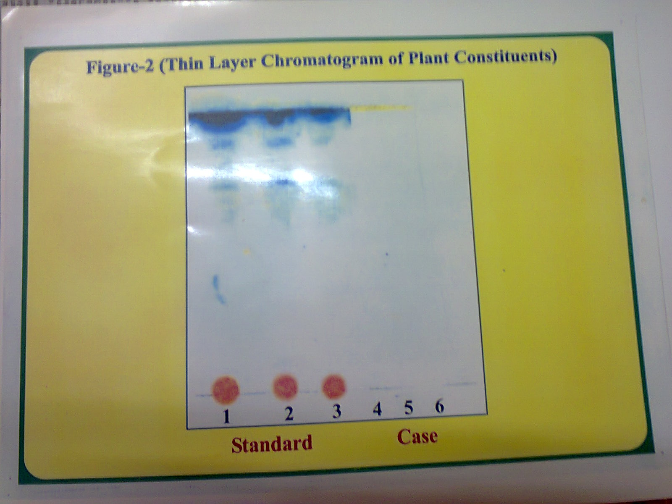
Figure-2 (Thin Layer Chromatogram of plant Constituents)
TABLE: 2 CHEMICAL CHARACTERISTICS OF STANDARD SAMPLE AND CASE SAMPLE
S.No | Chemical Characteristics | Standard Sample | Case Sample
01 | Colour & Appearance | Red/Hand made | Black/Cast die
02 | pH of aqueous extract | 11.46 | 6.88
03 | Chlorides | Present | Absent
04 | Sulphite | Present | Traces
05 | Sulphide | Absent | Present
06 | Plant Constituents by TLC | Present | Absent

2.6 RESULTS AND DISCUSSION
Figure (1) showed the Photo image of Herbal Statue of Standard and Case Sample. As per the Siddhars formulation, the medicated Navapashana Herbal Statue was prepared with Kattu (calcined pashana Powder) mixed with Herbal Extracts in suitable proportions to have a final stage. After the completions of all treatment, the Herbal statue will be red in colour and the statue will be obtained only by Handmade Sculpture. It is practically not possible to obtain by cast method using die as in the case of other idols. After careful Physical examination it is understood that the Case Herbal Statue was obtained only by Cast method but not by Handmade Sculpture. The Case Sample was black in colour but not red.

Thin Layer chromatography showed the presence of Phyto (plant) constituents which gives an indication of the usage of Herbal Extracts. Figure (2) showed that the Case Sample does not shown any characteristic colour which in turn gives an indication of non usage of Herbal Products where as the standard Herbal Navapashana powder gives multiple grey-blue spots.

Level of Sulphur gives a very good indication that the Case Sample is a Simulated Statue. In general, Navapashana Herbal Statue contains Sulphur in trace level. They add Sulphur to arrest the fluidity of Mercury which becomes Mercury Sulphite and after calcinations it liberates Sulphur dioxide and the presence of elemental Sulphur is negligible. The higher level of Sulphur (28.48%) in Case Sample (Table:3) provides valuable information regarding simulation.

TABLE: 3 LEVEL OF METALLIC & NON - METALLIC CONSTITUENTS IN CASE AND STANDARD STATUE
S.No | Constituents  (Metallic & Non-Metallic) | Standard Statue  (%w/w) | Case Statue  (%w/w)
01 | Arsenic | 3.17 | 46.79
02 | Mercury | 13.06 | 2.30
03 | Sulphur | 0.10 | 28.48
04 | Lead | 0.85 | 15.49
05 | Iron | 0.02 | 0.06
06 | Tin | Traces | 2.56
07 | Copper | Traces | Traces
08 | Zinc | Traces | Traces

Level of Arsenic, Lead, Tin and Mercury of Standard Navashanam and Case Sample were analysed, based on the results from Table:3 it is very clear that there is a wide difference in concentrations of Arsenic, Lead, Tin and Mercury. Siddhars preparation of Pashanam normally contains calcined powder of Arsenic & Mercury and Bhaspam (ash) contains low levels of Arsenic and they never use Lead. The calcinations process converts metals into their oxides and the aqueous extract exhibits alkalinity. The aqueous extract of Case Sample is neutral but not alkaline as in the case of Standard (Table:2)

2.6 CONCLUSION
The level of Arsenic, Sulphur and Lead in Case Sample was found to be very high when compared to Standard Herbal Statue. On the other hand, the level of Mercury is high in Standard Sample when compared to Case Sample which is a proof of Siddha Preparations. Absence of Plant constituents in Case Sample showed that the Statue is not a geneuine. This will not have any medicated power of curing diseases as in the case of Standard Medicated Herbal Statue but will act as a cumulative poison exhibiting adverse effect. The Forensic Examination has thrown light in differentiating the Fake from the Original Herbal Statue.
Toxic Effects of Lead

- Hematologic Effects
Lead has multiple hematologic effects,ranging from increased urinary porphyrins, coproporphyrins, δ-aminolevulinic acid (ALA), and zinc-protoporphyrin to anemia.

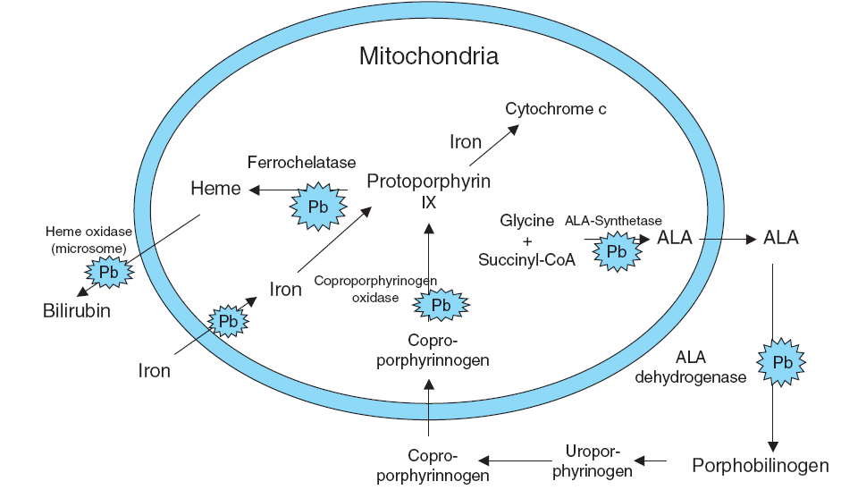

Toxic Effects of Suphide derived from Sulphur

On the other hand, if anybody consumed this spurious herbal preparations if may lead to sulphide poisoning and the following effects on human health.
- Neurological effects & behavioural changes.
- Disturbance of blood circulation .
- Heart damage & Reproductive failure.
- Damage to immune systems.
- Stomach & gastro intestinal disorder.
- Damage to liver & kidney functions.
Toxic Effects of Arsenic
- Heart damage & Reproductive failure.
- Damage to immune systems.
- Stomach & gastro intestinal disorder.
- Hemacturia & Lymphopenia
- hemolysis
- Damage to liver & kidney functions.
- Skin cancer
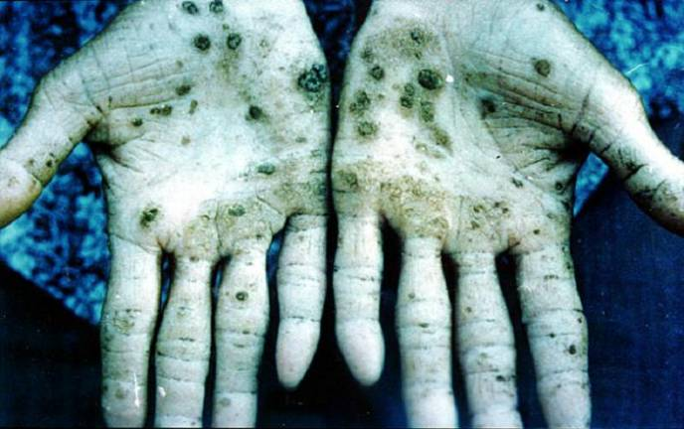
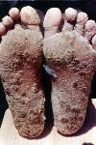

ACKNOWLEDGEMENT
The authors would like to thant Tr.Siddhar Jeyaraman for providing Standard Sample of Navapashana Herbal powder and his valuable guidance. Authors are grateful to Tr.E.D.Thamarai Selvan, FSD,Chennai 600 004 for his literature Support. We thank Mrs.Jamuna Sivasankaran and Mrs. Manjula Devi of Instruments Division of FSD, Chennai 600 004 for their excellent technical co-operation. We are grateful to Tr.KuttalamPillai, Photo Section, FSD, Chennai 600 004 for his valuable photography. We sincerely thank one and all the volunteers who have supported in achieving this study.
REFERENCES

- Arthur.I.Vogel,”Quantitative Inorganic Analysis”’ 3rd edition 1961.
- Siddhar.M.M.Jeyaraman, “Medicated Nava Pasana Herbal Statue” 1st edition 2001.
- Indian Medical Practioners co-operative Pharmacy and Society, Chennai, “Formulary of Siddha Medicines” 5th edition 2000.
- Lyle E.Cracker, James.e.Simon, “Herbs, Spices and Medicinal Plants” Vol. I to IV-2002.

